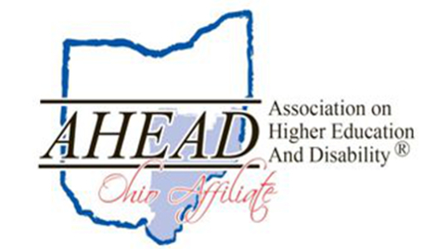

Ohio AHEAD Annual Conference 2016
  - Disability Matters
  - Friday, October 21, 2016
  - Kent State University at Stark Conference Center
  - 6000 Frank Avenue NW, North Canton, Ohio 44720

Schedule of Events (See http://ohioahead.org for full session descriptions.)
8:00 – 8:45 Registration/Check-In/Vendor Exhibits/Light Breakfast
8:45 – 10:30 Welcome and Featured Speaker, Adam Meyer, Director of Inclusive Education Services and Student Accessibility Services at University of Central Florida

Maximize your Collaborative Efforts by Being Intentional with Your Office Brand
All businesses have a brand that creates a perception for their customers. A disability office is no different. Based on how your office functions, the language it uses, its customer service approach and more, students, faculty and staff develop a certain awareness and opinion of your office operations. A positive perception will maximize collaborative efforts. A negative perception will create a perpetual uphill battle. This session will explore some concepts of brand awareness and strategies to maximize your office brand.
10:45 – 11:45 Concurrent Session 1/Vendor Exhibits
12:00 – 1:30 Lunch and Ohio AHEAD Business Meeting (beginning at 12:30)
1:45 – 2:45 Concurrent Session 2/Vendor Exhibits
3:00 - 4:00 Concurrent Session 3
CRC/LSW/LISW/PC/PCC Continuing Education Application Pending
Visit http://ohioahead.org/conference/ for more conference information

Registration Information
Go to the following website to register: https://ohahead.wufoo.com/forms/2016-ohio-ahead-registration/
- Conference Registration: $85 (current Ohio AHEAD members should receive a code for $30 off)
- Conference Registration + 2017 individual membership*: $110
- Student Conference Registration: $25 (includes membership for 2017)
*Institutional members should apply for/renew institutional memberships separate from conference registration. Visit http://ohioahead.org/membership/ for more information.

Directions and Accommodations
Visit http://www.kent.edu/stark/cucc/directions-maps for specific directions. For Overnight Accommodations, please visit http://ohioahead.org or http://www.kent.edu/stark/cucc/area-guide.

For conference information, contact Amanda Weyant, Ohio AHEAD 2016 Conference Chair at 330-244-5047 or e-mail starksas@kent.edu

Arriving on Thursday? Ohio AHEAD is sponsoring an evening meet-and-greet on Thursday, October 20.
More details to come!

