OH-AHEAD
Southeast Ohio Disability Consortium
Joint Conference
October 25, 2013 – Ohio University
Athens, Ohio
Ohio: With Access and Justice for ALL
FALL CONFERENCE REGISTRATION INFORMATION
Friday, October 25, 2013
9:30 A.M. to 4:00 P.M.
Registration begins at 8:30 A.M.
Ohio University
Baker University Center Ballroom A
Join your disability services colleagues from across the state for the fourth annual Ohio Association of Higher Education and Disability conference. Planned in partnership with the Southeast Ohio Disability Consortium (focused on supporting the transition of high school students to higher education), this year’s conference will also offer the opportunity to network with disability services colleagues as well as educators in high schools who support the transition of students to post secondary education.
To attend, complete the 2013 OH-AHEAD Conference Registration Form
Concurrent session topics will include:
- Working With Student Veterans
- Applications for the iPad
- Preparation Programs for High School Students
- Implementing AHEAD Documentation Guidelines
- Selecting Assistive Technology
- Coordinating Note-taking Services
- Writing IEPs for Transition to Post-Secondary Education
- Network with Vendors
- ...and more!
Keynote Presentation:
Ken Petri, Director of the Web Accessibility Center at Ohio State University is the 2013 Keynote Presenter. Mr. Petri will address IT Accessibility Strategies within the changing legal climate.
Schedule of Events:
8:30-9:30: Registration/Check-In/Vendor Exhibits/Light Breakfast
9:30-10:00: Welcome and OH-AHEAD Business Meeting
10:15-11:15: Keynote Session
11:30-12:30: Concurrent Session 1/Vendor Exhibits
12:30-1:30: Lunch and Vendor Exhibits
1:45-2:45: Concurrent Session 2/ Vendor Exhibits
3:00-4:00 Concurrent Session 3

Vendors in Attendance:
_______________________________________________________________
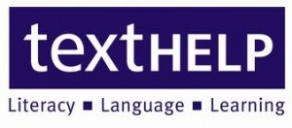
TEXTHELP, Inc.Texthelp provides literacy software solutions for individuals, K-12, higher education, and publishers. Texthelp solutions include: Read&Write, Fluency Tutor, and SpeechStream. Read&Write provides literacy support on the Desktop, in the Cloud, and on an iPad. Be sure to ask about or newest solutions for Google Apps in Education.
_______________________________________________________________
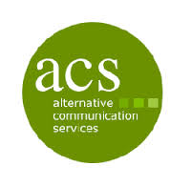
Alternative Communication Services (ACS) exists to provide the highest quality voice-to-text services possible, delivering these services to consumers throughout the world, and recognizing the unique strengths of each individual in the process. Our voice-to-text options include:
- CART/Captioning: Verbatim services, where every word is transcribed at a minimum accuracy level of 98.5% accuracy.
- Text Interpreting (TypeWell or C-Print): Meaning-for-meaning transcription of English text, typically found in the educational environment.
Post-production Captioning: For events that have already taken place we are able embed captioning into any type media file.
_______________________________________________________________
Freedom Scientific
Freedom Scientific is the largest worldwide manufacturer of assistive technology products for those who struggle with reading and writing, are blind or have low vision. All of these products are tested and guaranteed to work together. Our WYNN program is research based and helps students with comprehension, studying, note taking, reading and writing. It provides access to those that struggle with printed material. Freedom Scientific also has a whole line of low vision products and products for individuals that are blind.

_______________________________________________________________
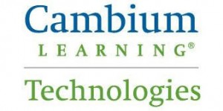

Cambium Technologies
Cambium Learning creates software and hardware products serving students ranging from PreK to adult. Cambium Technologies is vendor of Kurzweil, the scan and read software that makes printed or electronic text accessible to people who are blind or visually impaired. It combines technologies such as scanning, image processing, and text-to-speech with communication and productivity tools to ease and enhance users' reading, writing, and learning experiences.

Please click this OH-AHEAD Resources weblink for a list of vendors providing resources and information at this year’s conference

