Testing and Disability Offices: Partners in Access and Success

Panel
Jennifer Radt
Sara Rieder Bennett, Ph.D.
- Assistant Director of Testing and Licensed Psychologist, Counseling & Testing Center, The University of Akron
- President, Ohio College Testing Association
Kelly Kulick, M.Ed., CRC
Director of the Office of Accessibility, The University of Akron
Jessica DeFago, M.A.
Associate Director of the Office of Accessibility, The University of Akron
Heather Vennekotter, LLPC, MRC
Testing Center and Accommodative Services Coordinator, Rhodes State University

Goals for Panel
- Provide overview of three campuses’ approaches to accommodative testing
- Define collaboration and identify barriers and supports to effective collaboration
- Present lessons learned for successful collaboration between our offices
- Panel question and answer, and group discussion

Background on Accommodated Testing
- Increasing prevalence, diversity, and needs of students with disabilities nationwide
  - ADA Amendments Act
  - Decreased or stagnant institutional resources
  - Need for collaboration between service-provision offices
- Data from The University of Akron: 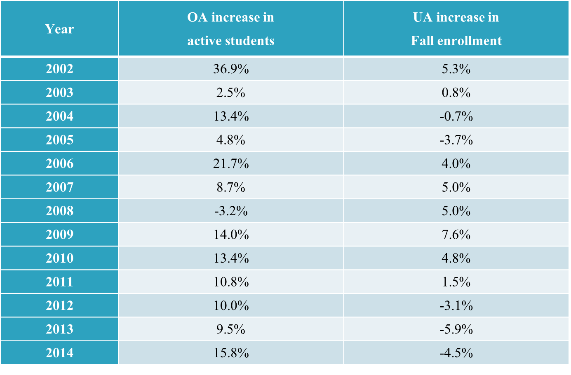

- Accommodated Testing in UA’s Counseling & Testing Center (Jan-June) shows 215% increase from 2011:
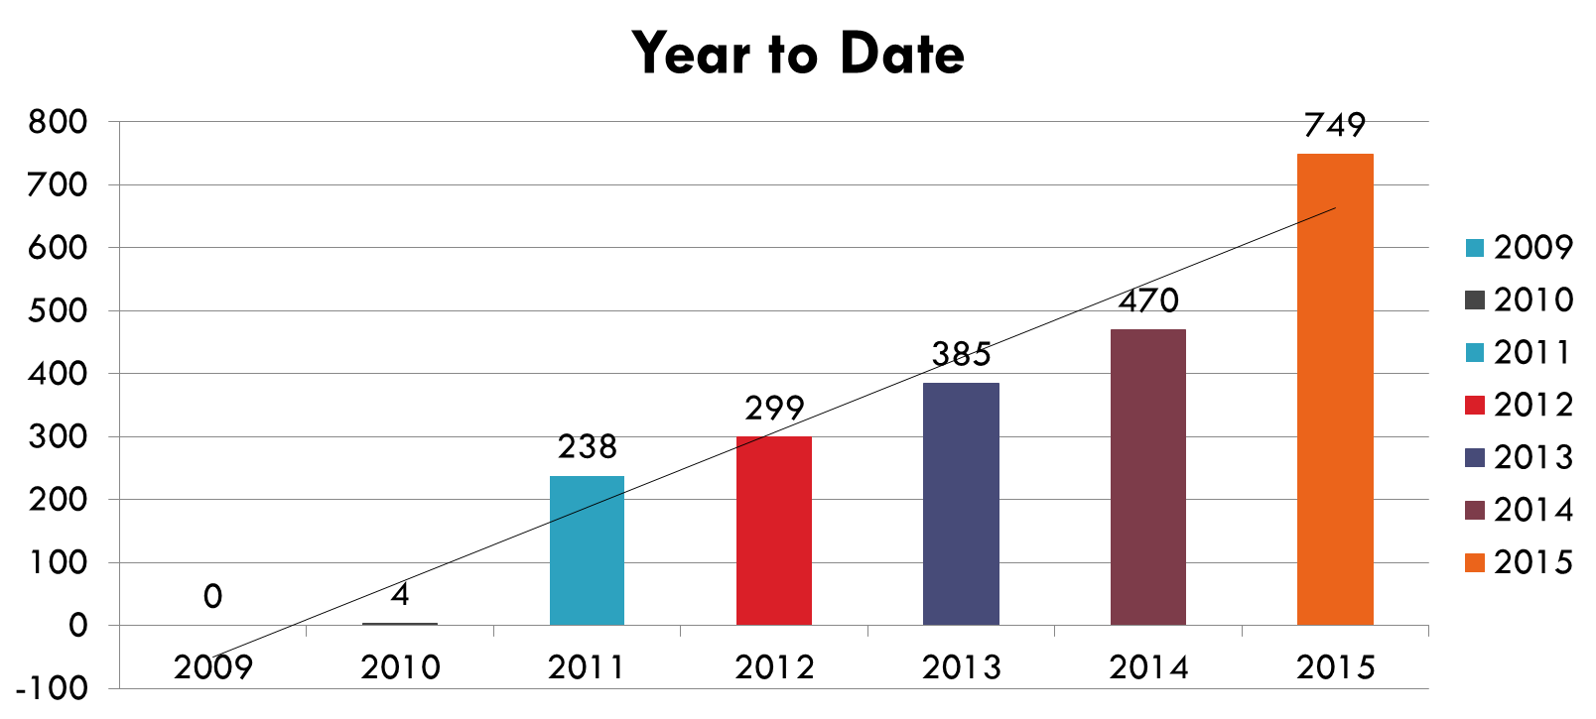

- Models for Accommodated Testing:
  - Instructor Delivery
  - Disability/Accessibility Office Delivery
  - Test Center Delivery
  - Collaborative – maximizes benefits and reduces limitations of other models
- The University of Akron model – six years of collaborative testing between OA and CTC:
  - Testing accommodations determined with documentation and intake at OA
    - Extended time: specific amount depends on impact of disability, determined by Disability Specialist
    - Distraction reduced space – no guarantee of private/distraction free space
    - Test proctors for reading/scribing
    - Use of technology – computers, CCTV, adaptive software, etc. Students not to use personal devices for testing.
  - Cases assigned based on accommodation need and how proctors function in each setting:
    - OA – individualized accommodation based on need of student.
    - CTC – proctors monitor testing environment for students with disabilities, distraction reduced environment, extended time, access to materials such as computer/calculator
    - Students maintain option to take tests with class without accommodations; with accommodations provided by instructor; at CTC or OA as assigned; or at Computer Based Assessment & Evaluation if required of the course (i.e. Springboard exam).
- Rhodes
- UC Clermont

Necessary Conditions for Collaboration
“Relationships are the currency of partnerships” (Colucci et al., 2002, p., 218)
- AHEAD defines as: “people with common concerns and needs put their heads together to arrive at a mutual solution”
- Collaborations often fail…why?
  - They require: layers of administrative oversight; creation of new policies; commitment of resources/staff time; recognition that the partnership creates a win-win situation; good past relationships, goals, and communication
  - Barriers are prevalent: turfism; lack of ownership by stakeholders; lack of power in decision-making; unfavorable attitudes about collaboration
- Melaville & Blank (1991) Five Principles of Collaboration:
  - Partnership between diverse stakeholder leads to more comprehensive identification of issues and solutions
  - Establish common goals to guide activities
  - Jointly plan, implement, and evaluate services by whole group
  - Commit resources to achieve mutually identified vision for services
  - Delegate individual responsibilities to group members to full goal of whole group
- Necessary Conditions for Collaboration:
- Open and non-defensive communication and inclusion of stakeholders in iterative decision-making process
- Adopting same procedures and models
- Collaborating on outreach and education of campus
- Recognition and promotion of one another’s expertise
- Collective philosophy and mission
- Maintaining a flexible learning orientation
- Restructuring to allow shared leadership and resources
- Building one another as team

References
ASHE. (2010), Partnerships and Collaborations. In ASHE Higher Education Report, 36, 1–15. doi: 10.1002/aehe.3602.
Association on Higher Education and Disability. (1996). Using collaboration to enhance service for college students with learning disabilities. Journal on Postsecondary Education and Disability, 12. http://www.ahead.org/publications/jped/vol_12
Colucci, K.L., Epanchin, B.C., & Laframboise, K.L. (2002). Collaborative professional development partnerships. In J.L. Paul, C.D. Lavely, A. Cranston-Gingras, and E.L. Taylor (Eds.) Rethinking Professional Issues in Special Education. P 209-229. Ablex Publishing: Westport, CT. 1-56750-626-7 ISBN.
Harbour, W.S. (2009). The relationship between institutional unit and administrative features of disability services offices in higher education. Journal of Postsecondary Education and Disability, 21, 138-154.
Horgan, T.R., & Scire, D. (2007). Enhancing access and building a campus culture of civic engagement and service-learning: A dual consortia approach. New Directions for Higher Education, 138, 83-94.
Melaville, A., & Blank, M. (1991). What it takes. structuring interagency partnerships to connect children and families with comprehensive services. Washington, D.C.: Education and Human Services Consortium.
O’Connor, T., Pettyjohn, H., & Duffy, T. (August 2013) NCTA National Conference Presentation. Accommodated Testing: Furthering the Discussion.

